Habitats
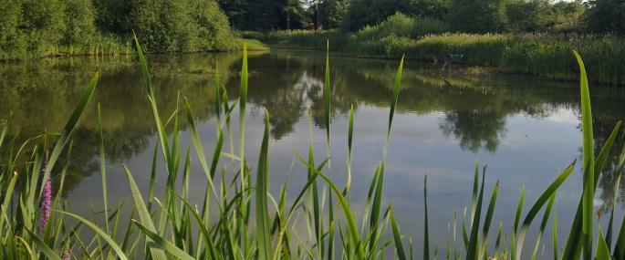

This programme offers pupils the chance to explore habitats in depth, carefully observing and classifying creatures which have adapted to the habitats surrounding us. The programme is flexible, used as a half day with River Studies, Orienteering or Teambuilding children can consolidate more than just their science learning.

Activities can be weather dependent so the day will include some or all of the following...
Activity | Description
Habitat Trail | Who lives where at Nell Bank? This activity gives children the chance to use prior learning about habitats and the freedom to explore the natural environment with minimal adult help.
Minibeasting | There’s more to the woodland floor than you think…find out just how mini the beasties are in the woods as well as the occasional hibernating frog, toad or sleepy newt. Through careful observation of the creatures caught pupils are introduced to basic classification.
Pond Dipping | Children use nets to catch and observe the creatures swimming in the depths of a Nell Bank pond and learn how many different species live in a freshwater habitat. Working in teams they carefully observe and begin to classify creatures looking for adaptations to freshwater environments.
Water Play | Put simply children are encouraged to play both independently and collaboratively with water, squirty things, rubber ducks and buckets. Slightly soggy Nell Bank fun guaranteed even on the sunniest day!
Woods Walk | A journey of discovery around a semi ancient bluebell woodland habitat. Children have the opportunity to learn how to identify tree species through careful observation of bark and leaves, follow animal tracks, see how different plants are adapted to living in different areas of the wood and create natural art which links to the minibeasting activity.
Adventure Play | Pupils have the opportunity to explore the adventure playground, slither down the tube slide, climb the bouldering wall, crawl along the tunnels and swing from the monkey rings. A brilliant way for groups to experience the freedom and physical challenge of adventurous play.

