
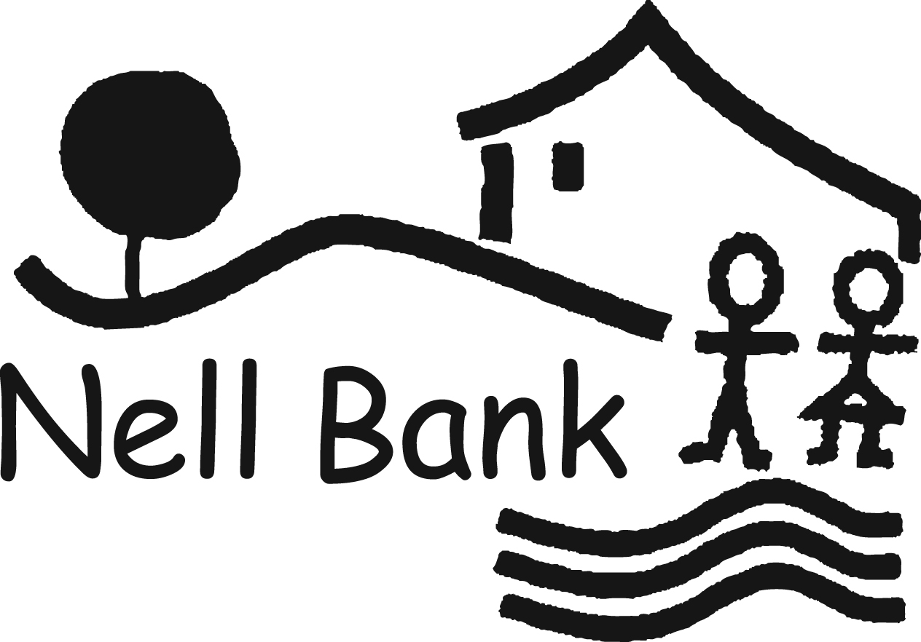

Habitats, Gruffalos,
bear hunts and national curriculum science
2014

Group leader guidance, ideas and resources for the classroom.
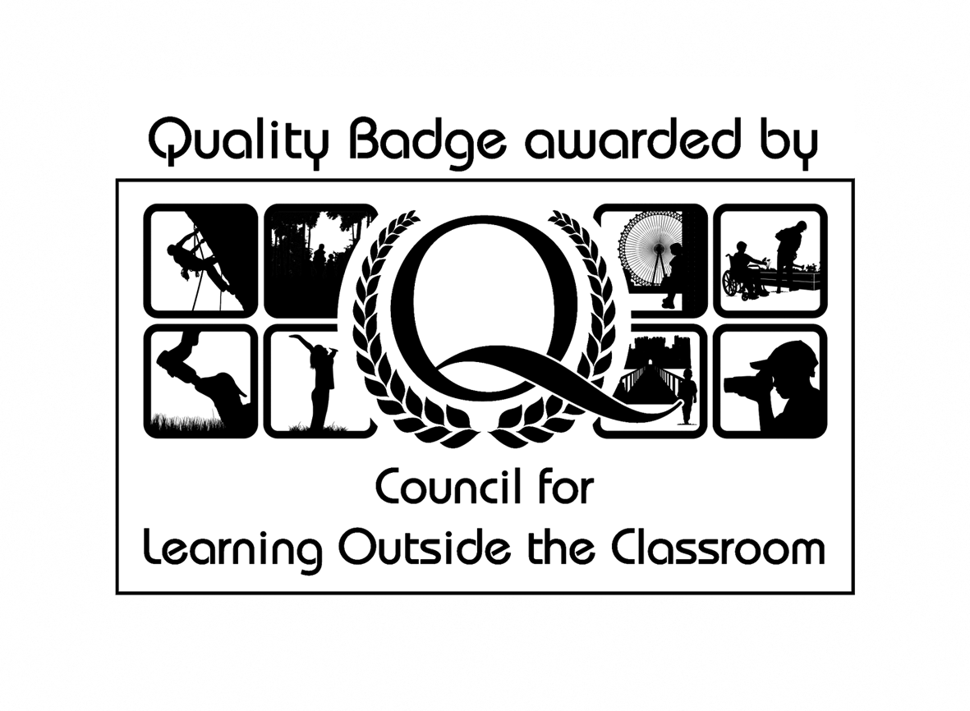

Science at Nell Bank
Our science programme is a popular element of all primary visits to Nell Bank and the pond dipping session continues to remain one of our most popular activities with adults, children and the Nell Bank staff. Pupils are given high quality instruction on one of the most powerful educational experiences we offer and it is a great way for pupils to learn the importance of contrasting habitats, how to protect as well as observe species and essential safety procedures around water.

Pre-visit preparation for adults
Before your visit to Nell Bank please make all other adults on the trip aware of their responsibilities during the visit:

All adults can support their pupils by:
- Remaining with the group to which they have been assigned
- Quietly assisting pupils who need help following instructions
- Being an active participant in the activities their group is presented with
- Filling out and returning a Nell Bank evaluation form.


Pre-visit preparation for pupils
Prior to the visit it is helpful if your pupils are given an opportunity to explore the focus of the visit. Work done in preparation in the classroom enables pupils to access new experiences, language and the environments more readily. By following the lesson plan on the following pages you will give your pupils the basic knowledge they need to get the most from their day at Nell Bank.

The basics
As part of a KS1 visit as well as KS2 it is helpful if pupils are aware that:

Plants manufacture their food from sunlight

Green leaves on a plant generate food so that it can grow and reproduce

All pupils should be developing awareness that animals cannot obtain food directly from sunlight. They take energy from food which has been made and stored in plants. Some animals feed directly on plants, primary consumers; others feed on animals which eat plants, secondary consumers. Adaptations of plants and animals in their environment are vital for their survival.

KS1 Identifying and observing

Pupils will be expected to carefully observe the creatures they catch during minibeasting and pond dipping sessions and will be given opportunities to explore the similarities and difference found in these creatures. Pictures of the types of creatures they will find are found on the branching keys at the back of this guide.

KS2 Identifying and observing
It is helpful if pupils have had experience of keeping a tally, working with a branching key (which can be found at the back of this guide) and are aware of the importance of size, shape, movement and colour in identifying creatures.

To extend the more able:
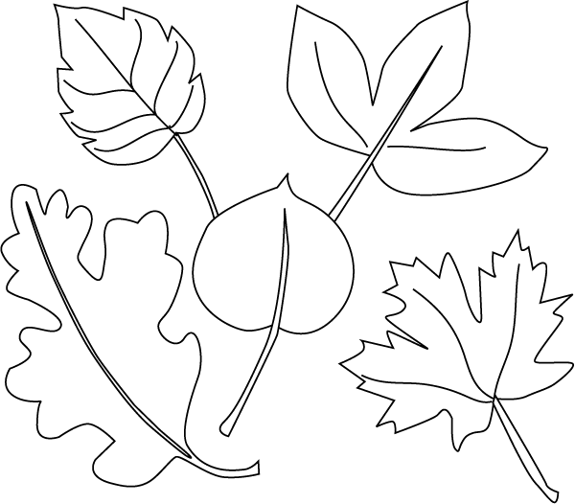
If appropriate at KS2 the following more detailed explanation could be introduced; Leaves draw in carbon dioxide gas from the atmosphere and chlorophyll in the leaves absorbs energy from sunlight. The plant’s cells use this energy to turn carbon dioxide and water into food in the form of sugar. The oxygen that is released during this chemical reaction passes out into the atmosphere through tiny pores in the leaves. This process is called photosynthesis.

How Nell Bank can help you teach the statutory requirements for science…
…and have fun doing it!
From KS1 through to KS2 a visit to Nell Bank gives pupils a rare chance to experience a sense of excitement and develop their curiosity of natural phenomena. The importance of first hand experiences cannot be underestimated and give that vitally important contact with the natural world that helps develop secure understanding of key blocks of knowledge and concepts in order to progress to the next stage.

For example:
Nell Bank in Year 1 ask pupils
What lives in a pond and do all the creatures look the same?
Nell Bank in Year 4 ask pupils to:
Use branching keys to identify, sort and name creatures living in the pond and explain how they have adapted to living in a fresh water habitat.

Without the first experience in KS1, the second visit in KS2 is limited by the lack of basic understanding, working scientifically and using different contexts will maximise pupils’ engagement with and motivation to study science.

The variety of activities, style of teaching and learning on offer at Nell Bank for primary school pupils gives the opportunity to experience and follow routes of scientific enquiry; the data they collect can be questioned, displayed in a variety of media and used to build secure foundations for pupils’ developing scientific knowledge…and everyone involved to have fun doing it!

The following pages contain lesson plans and work sheet ideas to get the most from your visit and the statutory requirements our activities cover.

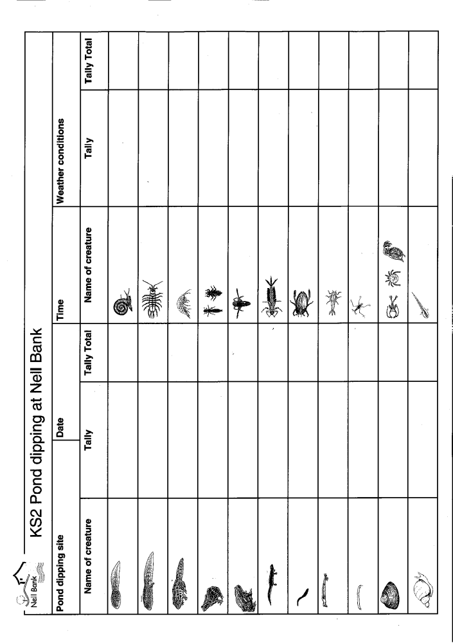
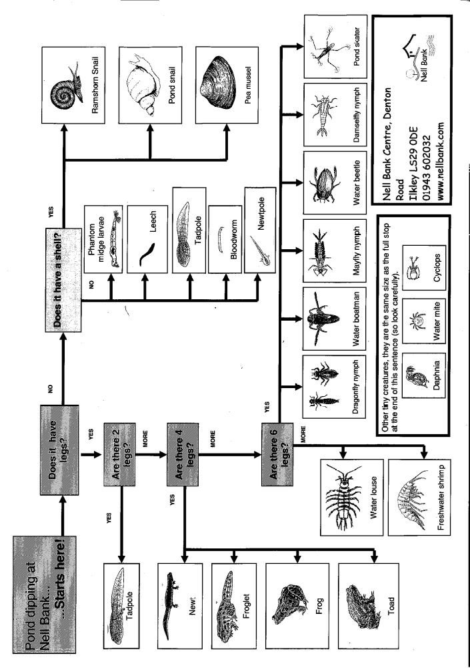

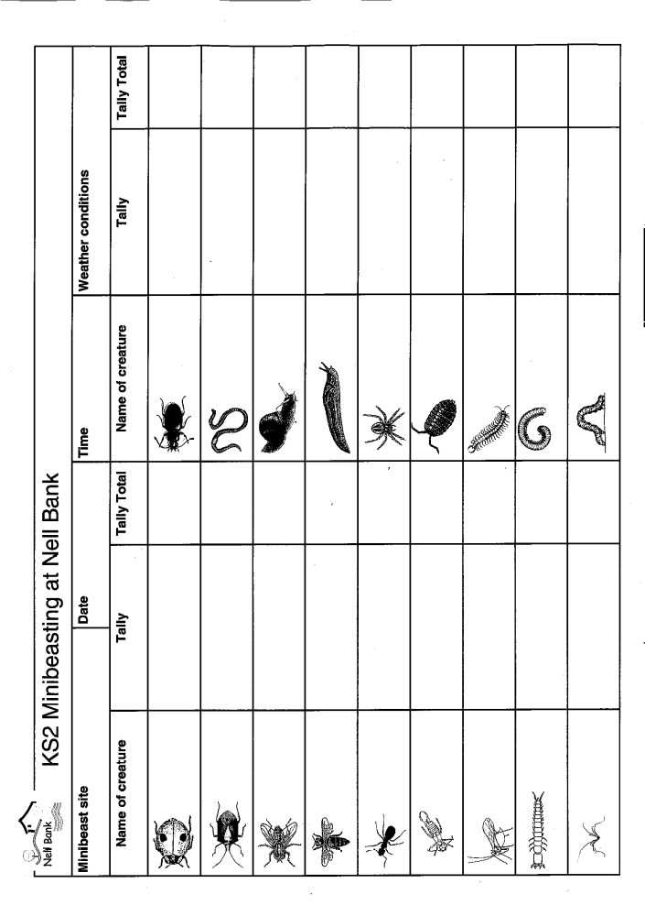

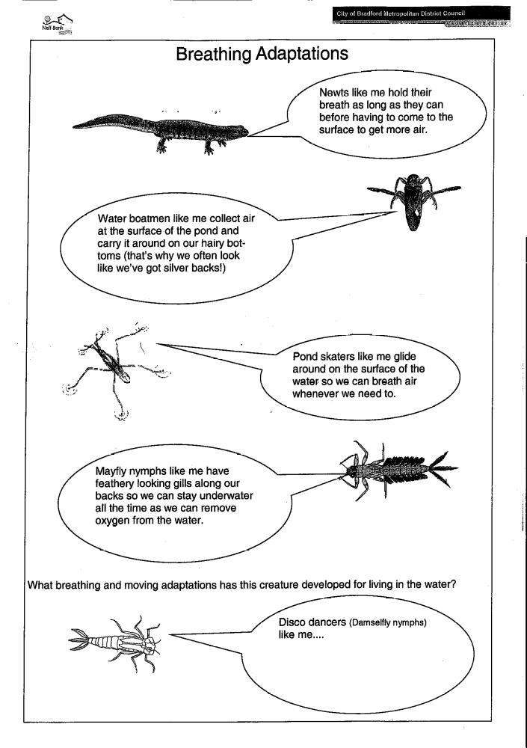

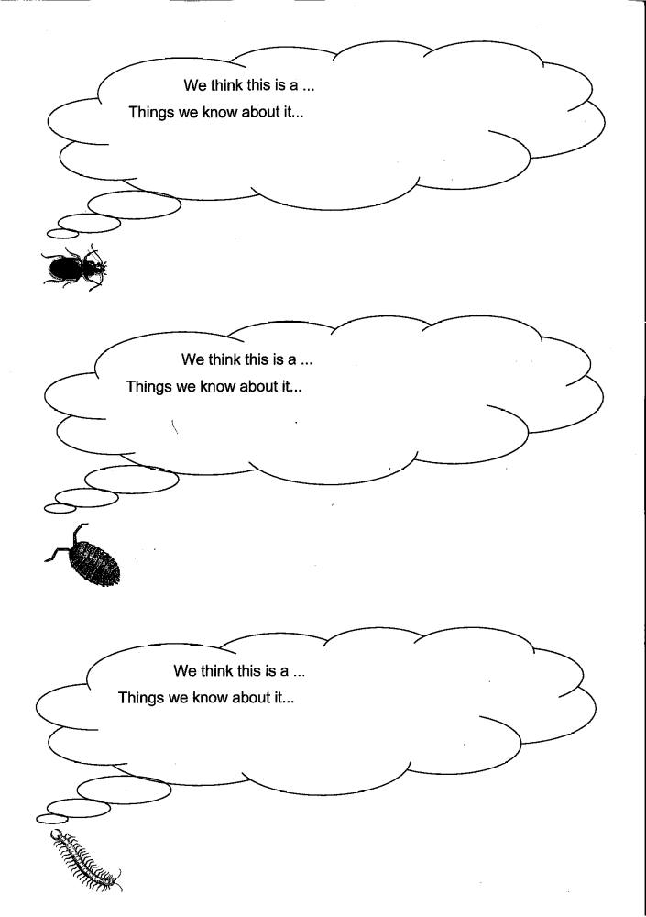

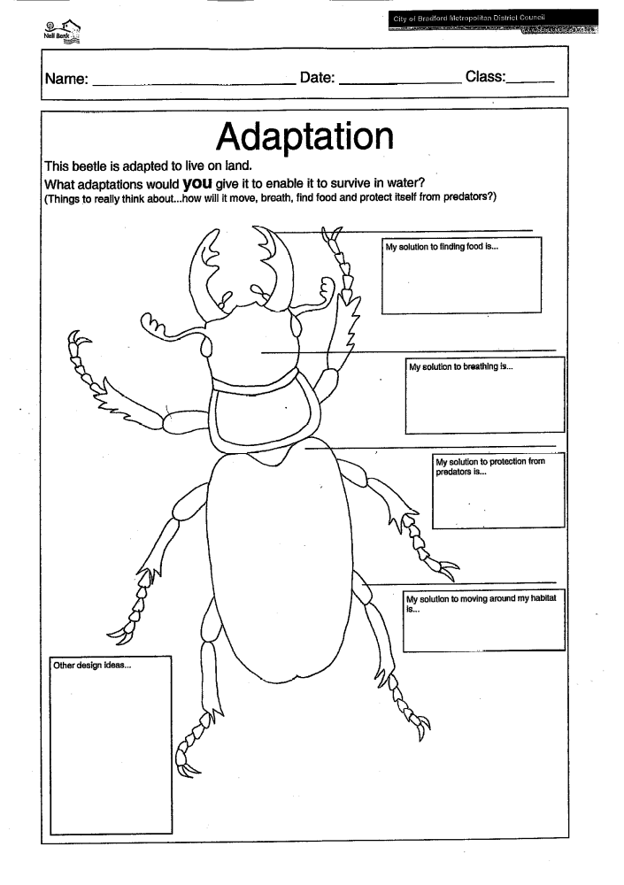

Nell Bank Pre-visit lesson plan
Date: | Class: KS1 | Topic for lesson: Habitats
Lesson objectives:
Working scientifically
- Asking simple questions and recognising that they can be answered in different ways
- Gathering and recording data to help in answering questions
Animals, including humans
- Identify and name a variety of common animals
- Find out about and describe the basic needs of animals, including humans for survival
Resource list: A class of enthusiastic children
Risk assessment: N/A classroom based
Starter Ask the class…  - What is a habitat? Try and come up with a definition…A habitat is a place where an animal lives.  - Can they name 5 different types of habitat? E.g. desert, woodland, ocean, ice, grassland, river, pond etc  - Which of those habitats do they think they’ll find at Nell Bank? And what sorts of animals would they expect to find living there?  In table groups ask the pupils to discuss…  - What do animals need from their habitats? Food, water, shelter, oxygen, space  - How many words can they think of to do with habitats? On a large sheet of paper ask pupils to create a knowledge map featuring anything they think is related to habitats e.g. predator, prey, food chain etc. |  |  | Vocabulary  habitat  environment  adapted  adaptation  larvae  nymph  food chain  food web  ecosystem  branching key  plant  feeding relationships photosynthesis  primary consumers  secondary consumers  predator  prey  camouflage
Main
Create a class glossary for the work they will be doing on habitats
- Pupils are assigned a word and are given the task of creating definitions (could also be illustrated). Each child’s page is added to the class or year group book.
- This can be revisited after the visit and additional information added
In preparation for the habitat element of the programme at Nell Bank
- What do they think pond dipping / Minibeasting is? Pupils discuss with a partner – list ideas on board
- What do they think they might find?
Intervention/Extension/Enrichment
If they were writing a list of rules for each activity what would they be?
In pairs work out one thing to think about for each activity and write down on a strip of paper e.g. clothing – how will they adapt to the environment at Nell Bank?
Plenary
Class glossary is a working document which can be added to as people find out more information. Homework could be to find pictures and information about minibeasts and pond creatures they are likely to find in the UK.
Main Outcomes
These activities are useful starting points for pupils and if revisited after the visit to Nell Bank pupils will be ale to add to this work giving you a clear picture of the development of their knowledge and understanding.

Nell Bank Follow up lesson plan
Date: | Class: KS2 | Topic for lesson:  Animals - minibeasts
Lesson objectives:
Living things and their habitats
- Explore and use classification keys to help group, identify and name a variety of living things in their local and wider environment
- Describe how living things are classified into broad groups according to common observable characteristics and based on similarities and differences, including micro organisms, plants and animals
- Give reasons for classifying plants and animals based on specific characteristics
Evolution and inheritance
- Identify how animals and plants are adapted to suit their environment in different ways and that adaptation may lead to evolution
Resource list: a class of enthusiastic children, pipe cleaner, plasticine, paper with creature names and speech bubbles, pictures of adaptations, pictures of creatures, outline of a beetle.
Risk assessment: N/A Class based
Starter:  In table groups write a list of all the creatures you found minibeasting at Nell Bank.  On the board  Get children to come up and write the name of the animal in the correct legs column and explain this is a way of classifying each creature.  In pairs/groups;  Use the speech bubble work sheet (previous pages) to get down all the information they know about a specific creature, colour, size, number of legs, habitat, predator/prey etc |  |  | Vocabulary  Choose a pupil/s to write down any science words which would impress a teacher next lesson.
  0 legs | 6 legs | 8 legs | Too many legs to count
Main:

Show the class how to make a beetle out of plasticine, pipe cleaners and craft sticks naming all the body parts; head, abdomen, thorax, legs, mandibles, antenna, eyes.

Ask pupils to make their own minibeasts, they can make a beetle or try others using the pictures on their speech bubble cards.
Intervention/Extension/Enrichment
The creatures we have made are based on the minibeasts we found at Nell Bank how would you adapt your creature to live in a water habitat?
Plenary
Revisit parts of an insect. Classify the creatures made. If I added adaptations like a breathing tube/flippers/gills where could the creature live?
Main Outcomes
Understanding of how animals adapt to their environment.
Developing understanding of classification
Other post-visit activity ideas
Literacy
Recounts and instructions
There are opportunities for children to write a recount of their day with us as well as write a set of instruction for how to minibeasts or pond dip.

Poems inspired by creatures they caught…
Today I saw a little worm
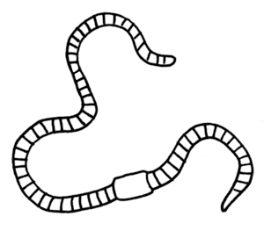
Wriggling on his belly.
Perhaps he’d like to come inside
and see what’s on the telly.
Spike Milligan, Silly verse for Kids
Puffin ISBN 0-14-030331-6

Jokes
How do you tell one end of a worm from the other?
Put it in a bowl of flour and wait ‘til it farts!
Brian Redhead Today programme Radio 4 (1980)
(hearing this as a 10 year old on serious national radio left an impression on me)
Numeracy
Pupils use the tally sheets from both minibeasting and pond dipping to create alternative ways of displaying data. Pool all the data from other classes or previous years and compare the results (previous data available on request by emailing: ruth.kata@bradford.gov.uk)

Number I caught | 5
Number I caught | 4 |  | 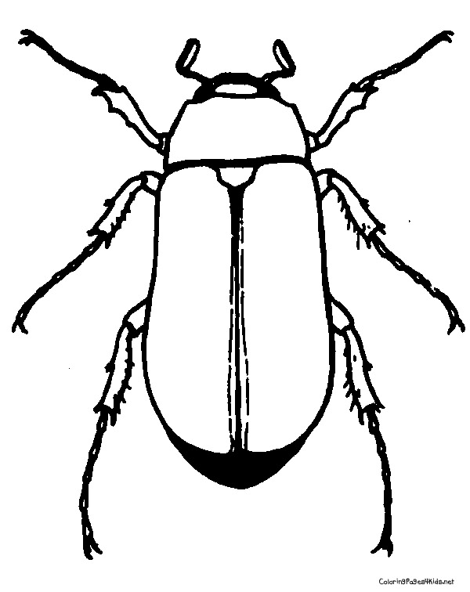
Number I caught | 3 | 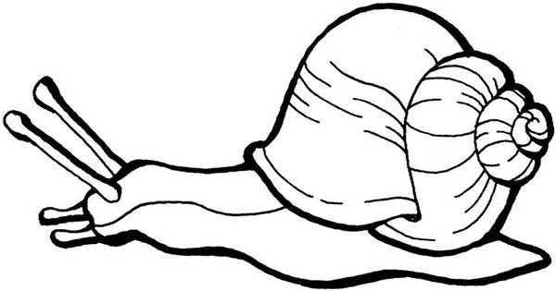
Number I caught | 2 |  |  |  | 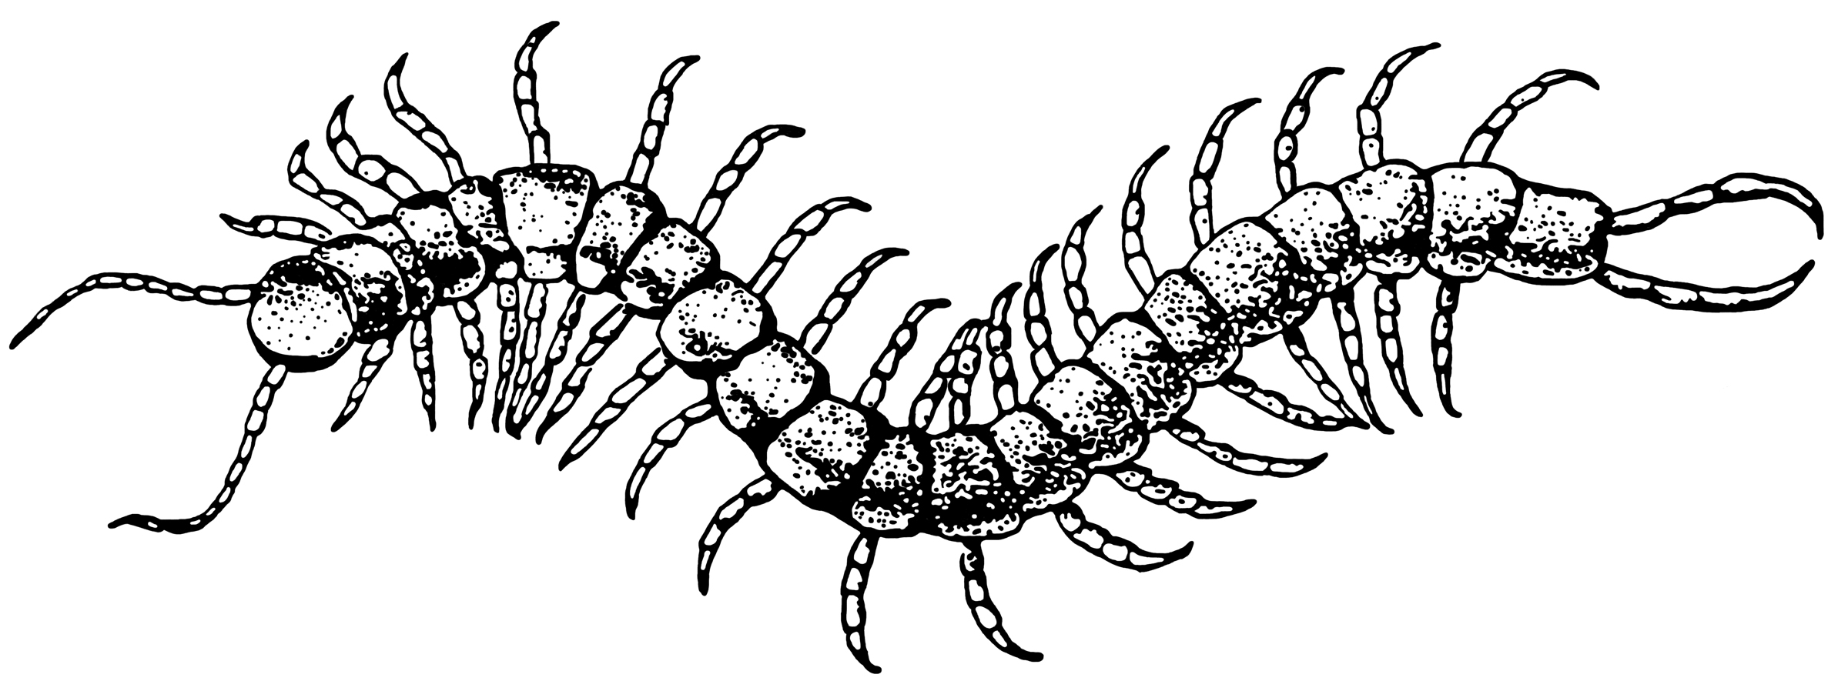
Number I caught | 1 |  |  |  |  | 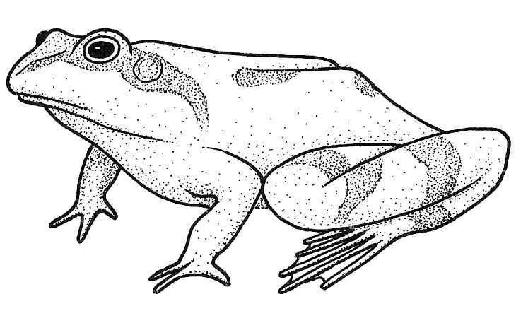
Number I caught |  | Snail | Beetle | Worm | centipede | Frog
 | Types of creature

Statutory Framework for the Early Years Foundation Stage
The following table illustrates how our activity programmes at Nell Bank can help you satisfy the standards for learning, development and care for children from birth to five.

Early Years and Foundation Stage
Prime areas of learning and development | Nell Bank activity programmes
Prime areas of learning and development | Animal Senses and adaptations | Bear Hunt | Gruffalo | Owl babies | Woods walk
Communication and language development involves giving children opportunities to experience a rich language environment; to develop their confidence and skills in expressing themselves; and to speak and listen in a range of situations. | J | J | J | J | J
Physical development involves providing opportunities for young children to be active and interactive; and to develop their coordination, control and movement. Children must also be helped to understand the importance of physical activity, and to make healthy choices in relation to food. | J | J | J | J | J
Personal, social and emotional development involves helping children to develop a positive sense of themselves, and others; to form positive relationships and develop respect for others; to develop social skills and learn how to manage their feelings; to understand appropriate behaviour in groups; and to have confidence in their own abilities. | J | J | J | J | J
Specific areas of learning and development | Nell Bank activity programmes
Specific areas of learning and development | Animal Senses and adaptations | Bear Hunt | Gruffalo | Owl babies | Woods walk
Literacy development involves encouraging children to link sounds and letters and to begin to read and write. Children must be given access to a wide range of reading materials to ignite their interest. | J | J | J | J | J
Mathematics involves providing children with opportunities to develop and improve their skills in counting, understanding and using numbers, calculating simple addition and subtraction problems; and to describe shapes, spaces and measures. | J | J | J | J | J
Understanding the world involves guiding children to make sense of their physical worlds and their community through opportunities to explore, observe and find out about people, places, technology and environment. | J | J | J | J | J
Expressive arts and design involves enabling children to explore and play with a wide range of media and materials, as well as providing opportunities and encouragement for sharing their thoughts, ideas and feelings through a variety of activities in art, music, movement, dance, role play and design and technology. | J | J | J | J | J

National Curriculum - Science programmes of study: key stages 1 and 2
The following table illustrates how our activity programmes at Nell Bank can help you satisfy the statutory requirements of the science National Curriculum.

Key stage one programmes of study - Science
KS1 Working scientifically - statutory requirements | Nell Bank activity programmes
KS1 Working scientifically - statutory requirements | Animal Senses and adaptations | Bear Hunt | Gruffalo | Minibeasting | Pond dipping | Woods walk
Asking simple questions and recognising that they can be answered in different ways | ☺ | ☺ | ☺ | ☺ | ☺ | ☺
Observing closely, using simple equipment |  |  |  | ☺ | ☺ | ☺
Performing simple tests | ☺ | ☺ | ☺ | ☺ | ☺ | ☺
Identifying and classifying | ☺ |  |  | ☺ | ☺ | ☺
Using their observations and ideas to suggest answers to questions | ☺ |  |  | ☺ | ☺ | ☺
Gathering and recording data to help in answering questions |  |  |  | ☺ | ☺ | ☺
KS1 Plants - statutory requirements | Nell Bank activity programmes
KS1 Plants - statutory requirements | Animal Senses and adaptations | Bear Hunt | Gruffalo | Minibeasting | Pond dipping | Woods walk
Identify and name a variety of common wild and garden plants, including deciduous and evergreen trees | ☺ | ☺ | ☺ | ☺ | ☺ | ☺
Identify and describe the basic structure of a variety of common flowering plants, including trees. |  |  |  |  | ☺ | ☺
Observe and describe how seeds and bulbs grow into mature plants |  |  |  |  | ☺ | ☺
Find out and describe how plants need water, light and a suitable temperature to grow and stay healthy |  |  |  |  | ☺ | ☺
KS1 Animals, including humans – statutory requirements | Nell Bank activity programmes
KS1 Animals, including humans – statutory requirements | Animal Senses and adaptations | Bear Hunt | Gruffalo | Minibeasting | Pond dipping | Woods walk
Identify and name a variety of common animals including fish, amphibians, reptiles, birds and mammals | ☺ | ☺ | ☺ | ☺ | ☺ | ☺
Identify and name a variety of common animals that are carnivores, herbivores and omnivores | ☺ | ☺ | ☺ | ☺ | ☺ | ☺
Describe and compare the structure of a variety of common animals (fish, amphibians, reptiles, birds and mammals, including pets) | ☺ |  |  | ☺ | ☺ | ☺
Identify, name, draw and label the basic parts of the human body and say which part of the body is associated with each sense. | ☺ |  |  | ☺ | ☺ | ☺
Notice that animals, including humans, have offspring which grow into animals | ☺ |  |  | ☺ | ☺ | ☺
Find out about and describe the basic needs of animals, including humans, for survival (water food air) | ☺ | ☺ | ☺ | ☺ | ☺ | ☺
Describe the importance for humans of exercise, eating the right amounts of different types of food and hygiene | ☺ |  |  | ☺ | ☺ | ☺
KS1 Seasonal changes - Statutory Requirements | Nell Bank activity programmes
KS1 Seasonal changes - Statutory Requirements | Animal Senses and adaptations | Bear Hunt | Gruffalo | Minibeasting | Pond dipping | Woods walk
Observe changes across the four seasons | ☺ | ☺ | ☺ | ☺ | ☺ | ☺
Observe and describe weather associated with the seasons and how day length varies | ☺ | ☺ | ☺ | ☺ | ☺ | ☺
KS1 Living things and their habitats - Statutory Requirements | Nell Bank activity programmes
 | Animal Senses and adaptations | Bear Hunt | Gruffalo | Minibeasting | Pond dipping | Woods walk
Explore and compare the differences between things that are living, dead and things that have never been alive | ☺ | ☺ | ☺ | ☺ | ☺ | ☺
Identify that most living things live in habitats to which they are suited and describe how different habitats provide for the basic needs of different kinds of animals and plants, and how they depend on each other | ☺ | ☺ | ☺ | ☺ | ☺ | ☺
Identify and name a variety of plants and animals in their habitats, including micro-habitats | ☺ | ☺ | ☺ | ☺ | ☺ | ☺
Describe how animals obtain their food from plants and other animals, using the idea of a simple food chain, and identify and name different sources of food. | ☺ | ☺ | ☺ | ☺ | ☺ | ☺

A poem for KS1 about the changing seasons….
A Little Elf
A little elf
Sat in a tree
Painting leaves
To throw at me

Leaves of yellow
And leaves of red
Came tumbling down
About my head

Key stage two programmes of study - Science
LKS2 Working scientifically – statutory requirements | Nell Bank activity programmes
LKS2 Working scientifically – statutory requirements | Habitat Trail | Woods walk | Pond dipping | Minibeasting | River studies
Asking relevant questions and using different types of scientific enquiries to answer them |  |  |  |  | 
Making systemic and careful observation and, where appropriate, taking accurate measurements using standard units, using a range of equipment, including thermometers and data loggers |  |  |  |  | 
Gathering, recording, classifying and presenting data in a variety of ways to help in answering questions |  |  |  |  | 
Recording findings using simple scientific language, drawings, labelled diagrams, keys, bar charts and tables |  |  |  |  | 
Reporting on findings from enquiries, including oral and written explanations, displays or presentations of results and conclusions |  |  |  |  | 
Identifying differences, similarities or changes related to simple scientific ideas and processes |  |  |  |  | 
Using straightforward scientific evidence to answer questions or to support their findings |  |  |  |  | 
LKS2 Plants – statutory requirements | Nell Bank activity programmes
LKS2 Plants – statutory requirements | Habitat Trail | Woods walk | Pond dipping | Minibeasting | River studies
Identify and describe the functions of different parts of flowering plants; roots, stem/trunk, leaves and flowers |  |  |  |  | 
Explore the requirements of plants for life and growth (air light, water, nutrients from soil, and room to grow)and how they vary from plant to plant |  |  |  |  | 
Investigate the way in which water is transported within plants |  |  |  |  | 
Explore the part that flowers play in the lifecycle of flowering plants, including pollination, seed formation and seed dispersal. |  |  |  |  | 
LKS2 Animals, including humans – statutory requirements | Nell Bank activity programmes
LKS2 Animals, including humans – statutory requirements | Habitat Trail | Woods walk | Pond dipping | Minibeasting | River studies
Identify that animals, including humans, need the right types and amount of nutrition, and that they cannot make their own food; they get nutrition from what they eat |  |  |  |  | 
Identify that humans and some other animals have skeletons and muscles for support, protection and movement |  |  |  |  | 
Recognise that living things can be grouped in a variety of ways |  |  |  |  | 
Explore and use classification keys to help group, identify and name a variety of living things in their local and wider environment |  |  |  |  | 
Recognise that environments can change and that this can sometimes pose dangers to living things |  |  |  |  | 
Construct and interpret a variety of food chains, identifying producers, predators and prey |  |  |  |  | 
LKS2 Living things and their habitats | Nell Bank activity programmes
LKS2 Living things and their habitats | Habitat Trail | Woods walk | Pond dipping | Minibeasting | River studies
Recognise that living things can be grouped in a variety of ways |  |  |  |  | 
Explore and use classification keys to help group, identify and name a variety of living things in their local and wider environment |  |  |  |  | 
Recognise that environments can change and that this can sometimes pose dangers to living things |  |  |  |  | 
LKS2 States of matter - Statutory Requirements | Nell Bank activity programmes
LKS2 States of matter - Statutory Requirements | Habitat Trail | Woods walk | Pond dipping | Minibeasting | River studies
Identify the part played by evaporation and condensation in the water cycle and associate the rate of evaporation with temperature |  |  |  |  | 
UKS2 Working scientifically - Statutory Requirements | Nell Bank activity programmes
UKS2 Working scientifically - Statutory Requirements | Habitat Trail | Woods walk | Pond dipping | Minibeasting | River studies
Planning different types of scientific enquiries to answer questions, including recognising and controlling variables where necessary |  |  |  |  | 
Recording data and results of increasing complexity using scientific diagrams and labels, classification keys, tables, scatter graphs, bar and line graphs |  |  |  |  | 
Reporting and presenting findings from enquiries, including conclusions, causal relationships and explanations of degree of trust in results, in oral and written forms such as displays and other presentations |  |  |  |  | 
Identifying scientific evidence that has been used to support or refute ideas or arguments |  |  |  |  | 
UKS2 Living things and their habitats – statutory requirements | Nell Bank activity programmes
 | Habitat Trail | Woods walk | Pond dipping | Minibeasting | River studies
Describe the differences in the life cycles of a mammal, an amphibian, an insect and bird |  |  |  |  | 
Describe the life process of reproduction in some plants and animals |  |  |  |  | 
Describe how living things are classified into broad groups according to common observable characteristics and based on similarities and differences, including micro-organisms, plants and animals |  |  |  |  | 
Give reasons for classifying plants and animals based on specific characteristics |  |  |  |  | 
UKS2 Animals, including humans | Nell Bank activity programmes
UKS2 Animals, including humans | Habitat Trail | Woods walk | Pond dipping | Minibeasting | River studies
Recognise the impact of diet, exercise, drugs and lifestyle on the way their bodies function |  | 
Describe the ways in which nutrients and water are transported within animals, including humans |  |  |  |  | 
UKS2 Evolution and inheritance – statutory requirements | Nell Bank activity programmes
UKS2 Evolution and inheritance – statutory requirements | Habitat Trail | Woods walk | Pond dipping | Minibeasting | River studies
Recognise that living things have changed over time and that fossils provide information about living things that inhabited earth millions of years ago |  |  |  |  | 
Recognise that living things produce offspring of the same kind, but normally offspring vary and are not identical to their parents |  |  |  |  | 
Identify how animals and plants are adapted to suit their environment in different ways and that adaptation may lead to evolution |  |  |  |  | 

Activities offered aim to be inclusive and are enjoyed by all ages and abilities. We also pride ourselves on the flexibility of our offer and our willingness to respond to customers evolving demands...

 | Age Group |  |  |  |  |  | Offered as part of a… |  | Is this activity inclusive?
Activity | EYFS | KS1 | LKS2 | UKS2 | KS3+ | Adults | day visit | residential | Is this activity inclusive?
Bear Hunt |  |  |  |  |  |  |  |  | 
Bear Homes |  |  |  |  |  |  |  |  | 
Gruffalo |  |  |  |  |  |  |  |  | 
Gruffalo Crumble |  |  |  |  |  |  |  |  | 
Little Brown Mouse House |  |  |  |  |  |  |  |  | 
Pond dipping |  |  |  |  |  |  |  |  | 
Meet the Chickens |  |  |  |  |  |  |  |  | 
Minibeasting |  |  |  |  |  |  |  |  | 
Water play |  |  |  |  |  |  |  |  | 
Animal Senses and Adaptations Programme
Squirrel Run |  |  |  |  |  |  |  |  | 
Badger Sniff |  |  |  |  |  |  |  |  | 
Mole Walk |  |  |  |  |  |  |  |  | 
Mouse Maze |  |  |  |  |  |  |  |  | 
Rabbit Run |  |  |  |  |  |  |  |  | 
Habitat Trail |  |  |  |  |  |  |  |  | 
Woods Walk |  |  |  |  |  |  |  |  | 
Schools Linking Network Programme
Circle Games |  |  |  |  |  |  |  |  | 
Scavenger Hunt |  |  |  |  |  |  |  |  | 
Woods Walk |  |  |  |  |  |  |  |  | 
Parachute Games |  |  |  |  |  |  |  |  | 
Exploring Habitats Programme
Habitat Trail |  |  |  |  |  |  |  |  | 
KS2 Pond dipping |  |  |  |  |  |  |  |  | 
KS2 Woods Walk |  |  |  |  |  |  |  |  | 
KS2 Minibeasting |  |  |  |  |  |  |  |  | 
Adventure play |  |  |  |  |  |  |  |  | 
Orienteering onsite |  |  |  |  |  |  |  |  | 
Orienteering woods |  |  |  |  |  |  |  |  | 
River Studies |  |  |  |  |  |  |  |  | 
Teambuilding Programme
Trust Trail |  |  |  |  |  |  |  |  | 
Duck Rescue |  |  |  |  |  |  |  |  | 
Custard Crossing |  |  |  |  |  |  |  |  | 
Save the Species |  |  |  |  |  |  |  |  | 
Magic Carpet |  |  |  |  |  |  |  |  | 
Prisoner |  |  |  |  |  |  |  |  | 
Circle in a circle |  |  |  |  |  |  |  |  | 
Initiative course |  |  |  |  |  |  |  |  | 
 | Age Group |  |  |  |  |  | Offered as part of a… |  | Is this activity inclusive?
Activity | EYFS | KS1 | LKS2 | UKS2 | KS3+ | Adults | day visit | residential | Is this activity inclusive?
Early Peoples’ Settlement Programme
Archaeological dig |  |  |  |  |  |  |  |  | 
Den building |  |  |  |  |  |  |  |  | 
Experimental Archaeology |  |  |  |  |  |  |  |  | 
Dustbin Game |  |  |  |  |  |  |  |  | 
Ecology Fieldwork Programme
Freshwater sampling - ponds |  |  |  |  |  |  |  |  | 
Freshwater sampling - rivers |  |  |  |  |  |  |  |  | 
Woodland ecology |  |  |  |  |  |  |  |  | 
Residential Activities
Mud Trail |  |  |  |  |  |  |  |  | 
Ilkley Moor walk |  |  |  |  |  |  |  |  | 
Three Bridges walk |  |  |  |  |  |  |  |  | 
Manor House |  |  |  |  |  |  |  |  | 
Other Activities offered
Work Related Learning |  |  |  |  |  |  |  |  | N/A
Work placements * |  |  |  |  |  |  |  |  | 
D of E camp ground |  |  |  |  |  |  |  |  | 
D of E Ambassador Award Scheme |  |  |  |  |  |  |  |  | 
CPD training – teachers |  |  |  |  |  |  |  |  | 
ITT Training – QTS, PGCE students |  |  |  |  |  |  |  |  | 
Community support Volunteers |  |  |  |  |  |  |  |  | 
Voluntary work |  |  |  |  |  |  |  |  | 
Trainee Tutor – 3 fulltime training positions per year |  |  |  |  |  |  |  |  | 
Aiming High |  |  |  |  |  |  |  |  | 
Meeting Room |  |  |  |  |  |  |  |  | 
Residential Short Breaks for families |  |  |  |  |  |  |  |  | 
Other Regular Events
Outdoor Classroom e.g. Marshfield |  |  |  |  |  |  |  |  | 
Specific Education Training courses |  |  |  |  |  |  |  |  | 
Outdoor Odyssey (Summer Hols) |  |  |  |  |  |  |  |  | 
Nell Bank Family Fun Day |  |  |  |  |  |  |  |  | 
Disability Rocks |  |  |  |  |  |  |  |  | 
Wharfedale Schools x-country events |  |  |  |  |  |  |  |  | N/A
Ilkley and District Riding |  |  |  |  |  |  |  |  | N/A
Musical theatre workshop |  |  |  |  |  |  |  |  | 
Play in a day e.g. Foxhill Primary |  |  |  |  |  |  |  |  | 
Big Challenge |  |  |  |  |  |  |  |  | 
CISV |  |  |  |  |  |  |  |  | 
Race for Life |  |  |  |  |  |  |  |  | N/A
2012/2013 - 33 Students ranging from Year 10 to Trainee Teachers have attended a 2+ week work placement at Nell Bank

