NELL BANK OUTDOOR EDUCATION CENTRE
New Residential Facility
Opened June 2016

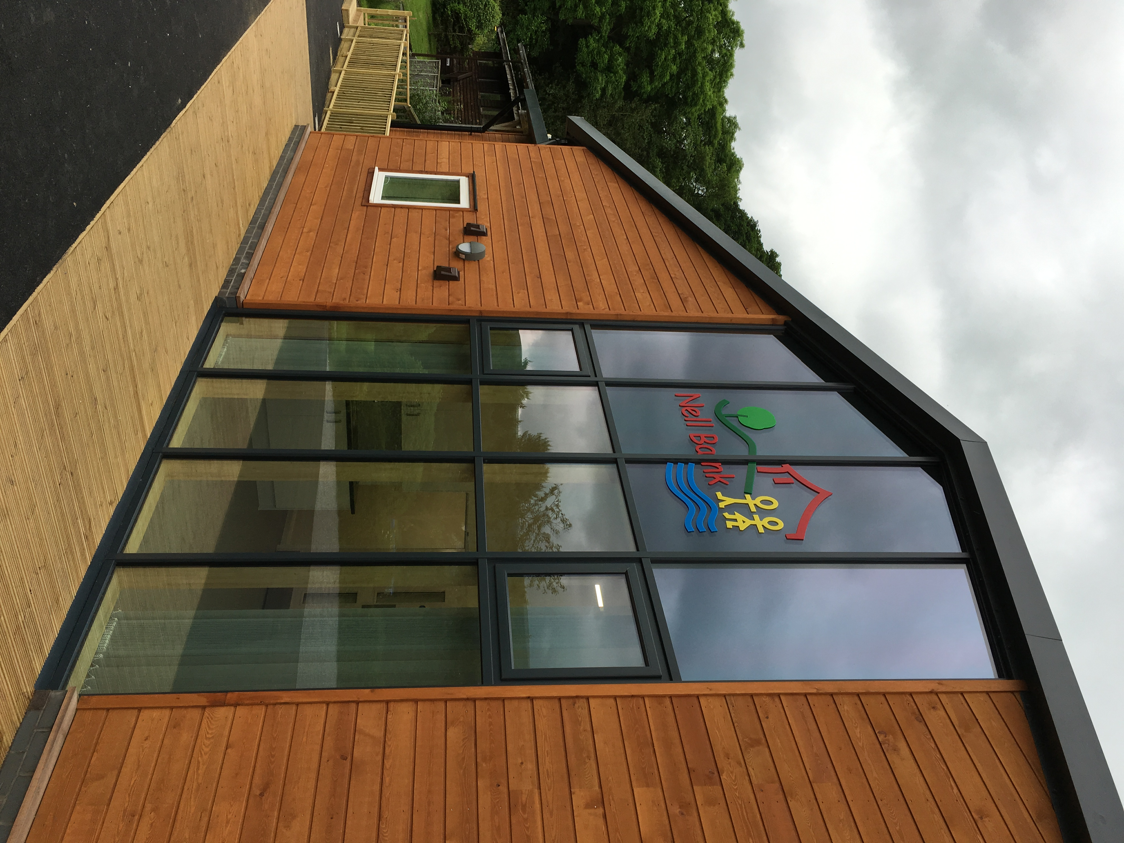

- Bookings now being taken for 2017/18
- Price £31 per person per night, including tutor-led activities
- Special Winter deal (November – February inclusive) at £22
- Fully equipped dining/kitchen facility on site for self-catering

BOOKING ENQUIRIES
kate.bothamley@bradford.gov.uk
Tel: 01943 602032
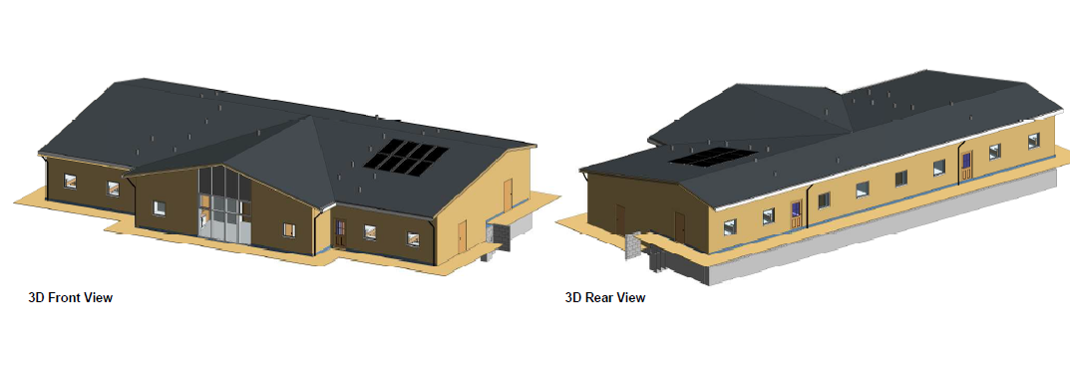
Staff lounge/kitchen area with stunning views of Ilkley Moor

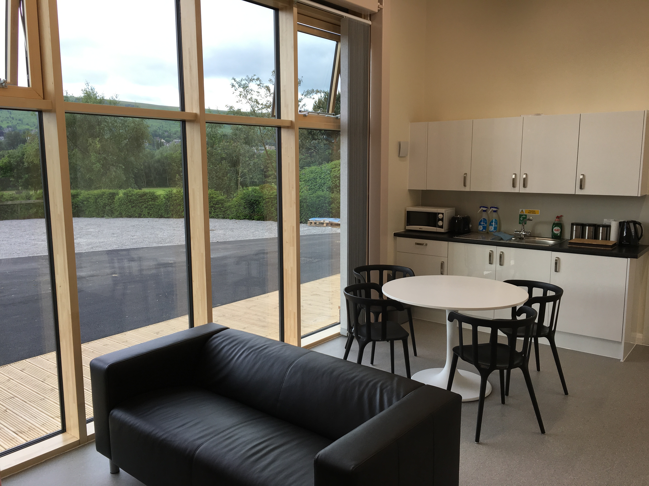

Dorm accommodation for up to 64 children
En-suite bedrooms for up to 8 staff



