Classic Car event near Box, Wiltshire

Informal Mid-Week Classic Car Meetup
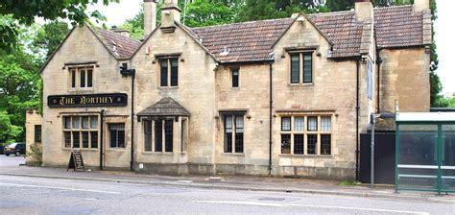
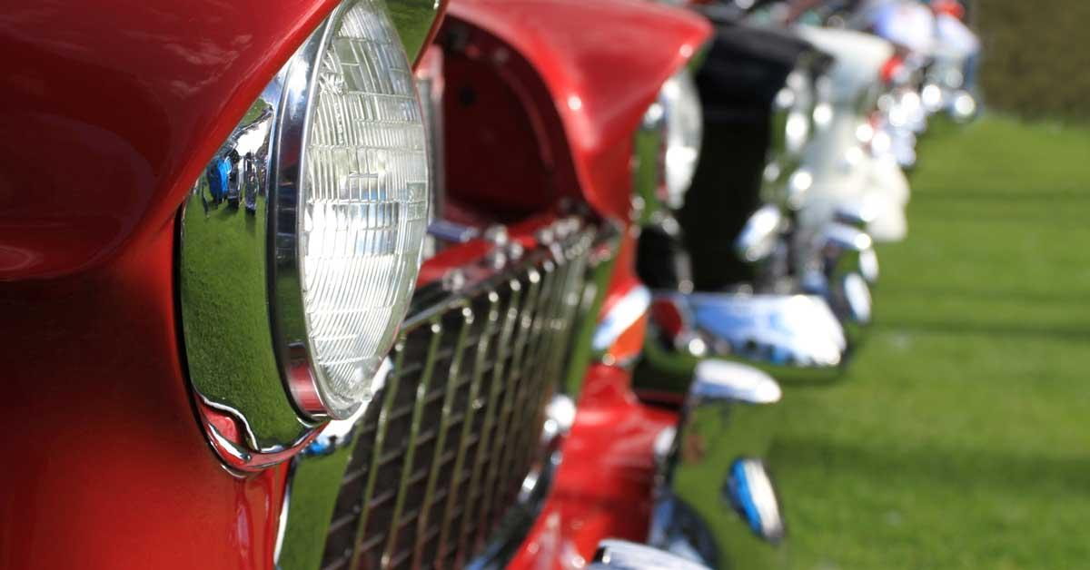

Wednesday 1st September, 3rd November & 1st December 2021 18:30
Looking to attend a nice informal event and meet new classic car owners in your area. The first event on 4th August was a resounding success, so further dates have been booked at the address below.
The Northerly Arms is on the A4 towards Box in Wiltshire SN13 8AE
https://www.ohhpubs.co.uk/the-northey-arms
This is the first mixed midweek classic car event I know of and am keen to start something new for our area.
Come for a drink, or engage in a sit down meal at this lovely pub with a huge parking area located right on the A4.
If you are interested in coming, please can you either email me on steve@teamhaven.com or text me on 07791 080 824 advising you are attending and if you would like a meal or just a casual drink.
People can order and pay for their own food, I will just need to make sure we have the indoor space booked.
Bring any car and I look forward to meeting you on the 4th August at the Northerly Arms in Box !!

Steve Grimes

