March 2018

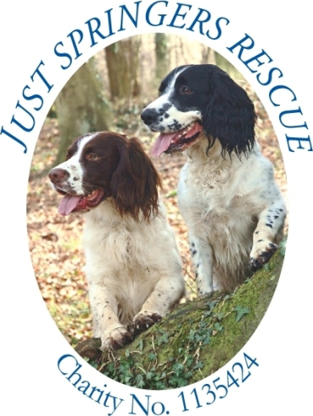
Patrons Phil Spencer, Jan Fennell

Dog to be Considered for rehoming- Key Questions to be answered in full please

Name of owner…………………………………………………………….

Address…………………………………………………………………….

……………………………………………………………………………..

Post Code…………………….

Tel Number landline………………………………………...

Mobile……………………………………………………….

Name of Dog………………………………………….

Pedigree Papers yes / no, if yes include a photo copy if possible.

Age………………colour………….. sex,…………… Castrated yes / no

Spayed yes / no if not when next season due………………………………

Micro chipped…………………………………….Docked yes / no if yes have you a docking certificate?.........................................................................................

How long have you had the dog……………………………………………………
……………………………………………………………………………...............

Reason for rehoming ……………………………………………………………...

…………………………………………………………………...…………..………………………

………………….……………………..………………………………………………………………

…………………………………………………………

Name and address of vet dog registered with ………………………………………………………………………………
………………………………………………………………………………
Dates of last Vaccination/Booster…………………………………………..

Kennel Cough………….. Worming,………………………………………

Flea Treatment and with what preparation…………………………………

Has the dog visited the vet in the past 15 months and why…………………

………………………………………………………………………………………………………………………………………………………………

If dog’s behaviour has changed recently, resulting in the dog being put up for rehoming, has the dog been examined by a vet to see if there is a medical reason for the dog’s behavioural change…………………………..………………………………………………………………………………………………………………………………………………………………

Training and Behaviour

House trained Yes / No Crate Trained Yes / No Been to training classes? Which? And for how long…………………………………………………………….

How does the dog greet you at door…….. Bark…………. Jump up?…… Quietly? Other?…………………………………………………………………………………

How does he behave when left? Chews………Barks…………Wets……… Steals food or toys……………..For how long can he be left for?…….……

Out on lead does he walk to heel? Does he Pull ? Does he wear a Gentle Leader? Halti? Easy Walk Harness? Any other sort of Harness or restraint ?

What is the dog’s recall like? Good Unreliable None circle which
Can the dog be loose in a Park?……………….Woods?…………………………….
Fields?……………………….Beach?…………………………………..……………
How does the dog behave with strange dogs?…………………………………..……
………………………………………………………………………………………..

With cats?……………… Other pets such as rabbits………………………. ………..
Horses……………………Cows………………..Sheep……………………pigs……. Birds…..………….any other livestock………………………………………

How does the dog behave with children under 5 years?………………………………
5-11 years………………………………12-18years……………………………….…

How does the dog travel and where in car? ……………………………………………………………………………………….... …………………….…………….………………………………………..……………

Can you examine the dogs Ears……. Teeth…….. Touch all parts of the body…………………….

Has the dog ever bitten ……… if so what sort of bite Mouthing, nip, snap, was the skin broken and if so did it require hospital treatment………………………………..

Where does the dog sleep?……………………………………………………………..

How much exercise does the dog get a day? And has this changed recently?.......................................
…………………………………………………………………………………………………………

What is the dog fed on, what make, how much and when?

………………………………………………………………………………………….

Any other relevant information please enter here carry on over page if required
……………………………………………………………………………..……………………………………………………………………………..……………………………………………………………………………………………………………..
………………………………………………………………………………………..
………………………………………………………………………………………….
………………………………………………………………………………………..

All questions must be answered before we can consider assessing the dog.

Data Protection: Any information given on the above form is confidential to the charity and will not be given to any third party.

Please tick here to agree for Just Springers Rescue to hold your personal information on their system.

Signed…………………………………………………………….. Dated…………………..

Please send form either by e-mail to westerlands1@btinternet.com
Or by post to 9 Three Arches Park
Three Arch Road
Redhill
RH1 5AD

